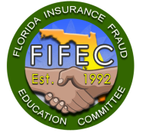
FIFEC
Florida Insurance Fraud Education Committee
“Fighting Insurance Fraud through Education and Commitment”
2023 FIFEC Sponsorship Bid Process Instructions
The Florida Insurance Fraud Education Committee is honored to invite you to become a 2023 FIFEC Conference Pearl Sponsor at our new location, the Renaissance Orlando at SeaWorld from July 12 – 14, 2023.

The Pearl Sponsorship is the highest level of recognition to those special firms who support FIFEC’s mission. These dedicated sponsors provide helpful items to our conference attendees which enhances the experience of attending FIFEC while enabling us to fund critical law enforcement scholarship grants.
Pearl sponsorships are determined by a closed bidding process starting at $2,500, in addition to covering the cost of the item selected. The highest bid earns the sponsorship.
Sponsorship Benefits:
- Complimentary conference admissions as indicated below:
Winning Bid Amount | $2,500 - $3,000 | $3,000 - $3,999 | $4,000 - $4,999 | $5,000 - $6,999 | 7,000 or higher
Complimentary FIFEC Conference Registrations | 1 | 2 | 3 | 4 | 5

- A list of 2023 FIFEC registrants, who have requested to be included in shared lists, 4 weeks before the conference date. A post-conference list will follow.
- A full color poster board displayed on a 30” across round high-top table affording a surface area for business cards, brochures, and other marketing materials for conference attendees.
- Recognition on the FIFEC Website as a Pearl Sponsor with a link to the firm’s website.
- Electronic slide advertisement projected during the conference in the convention center’s lobby area.
- Recognition at the opening ceremony.
- Recognition in the Pearl Sponsors section of the conference program.
- Pearl Sponsor ribbons for each of the firm’s members attending the conference to increase visibility.

Please scroll down to see the listing of available sponsorships. Bid on as many items as you’d like, then email your selections to Jesus Alvarez at sponsors@fifec.org on or before April 30, 2023.
We’re excited about the 2023 FIFEC Conference and look forward to your participation as a 2023 Pearl sponsor. If you have any questions or require additional information, please don’t hesitate to contact us.

Sincerely,

Jill Oliveri Jesus Alvarez, Kyle Herbert
904-495-3522 305-726-1362 561-421-5193

FIFEC is a 501(c)(3) educational organization. Your sponsorship donation is tax deductible and will help fund scholarship grants for law enforcement personnel and state prosecutors to attend FIFEC. Our 2022 Sponsors enabled us to award over 100 scholarships. Your generous support allows us to offer these scholarship grants.
2023 FIFEC Sponsorship Options Bid Sheets

Please review the available options below and decide which ones best suit your firm’s promotional needs. Please check the “box next to the items that interest you and indicate the dollar amount of your bid. You may bid on more than one item to increase your chances of being awarded a Pearl sponsorship. Each firm may have only one sponsorship, except for the Awards Luncheon Add-on Option.
If you are the highest bidder on multiple sponsorships, we will ask you to select your preference, and the other sponsorship will go to the next highest bidder. If there are tied bids, the highest bidders will be asked to re-bid, starting at the amount of the last bid, until we have a winner.
After your selections are set, please email this form to Jesus Alvarez at sponsors@fifec.org on or before April 30, 2023. The sponsorships are awarded that day so please don’t delay.

Hand Sanitizer Bottles Bid Amount:
We all know the value of these little bottles and their contents. Small bottles of hand sanitizer with your firm’s name and/or logo will be a very valued and useful item that our attendees will appreciate and use continuously before snack breaks, meals and after meetings. We recommend ordering 800 units.

Coffee/Tea Sponsor Bid Amount:
For some of us, this is the most important part of the day. We offer coffee and tea in the Exhibitor Hall during both continental breakfasts and at every break. Appropriate signage will recognize you as the sponsor of this most important of all libations at every breakfast and break. You aren’t expected to cover the entire cost of our coffee service. Your winning bid amount will be used to defray that expense. You may supply your own hot beverage cups or napkins with your firm’s name and/or logo to further extend your sponsorship presence.

Neck Wallet Sponsor Bid Amount:
Everyone is required to wear them - the All-Access pass to the conference activities that holds the attendees’ name tag. This is a visible opportunity to have your organization recognized daily throughout the conference. The neck wallet should be at least 5” x 6” to hold the name badge. We recommend ordering 1000 units.

Pen Sponsor Bid Amount:
Everyone needs one to write with during the conference so why not have your name on it! The pens will be distributed to all registered attendees for them to take back to their offices. Pens with stylus tips add additional functionality and visibility even after the ink has run dry. We recommend ordering 800 units.

FIFEC Website and Conference Wi-Fi Sponsor Bid Amount:
Every conference attendee visits our website several times. This sponsorship also provides Wi-Fi inside the convention center to conference attendees. The Wi-Fi sponsor will receive special recognition:
- The firm’s name will be incorporated into the Wi-Fi password that attendees will enter to gain access.
- The firm’s name and logo will appear on the main page when attendees enter the site.
- There will be additional signage at the Registration, Gifts & Operations desks displaying your Wi-Fi password and recognizing your sponsorship.
The sponsor will be responsible for $3,500 in addition to the bid amount.

FIFEC Conference Program Sponsor Bid Amount:
FIFEC Conference programs are available to each attendee and extras are available throughout the conference and are taken back home and kept for reference. The program sponsor will be acknowledged on the inside cover, as well as having a full color ad serving as the program’s back cover. The sponsor will pay $3000 towards the total cost of the program production, in addition to the bid amount.

Registration Bag Sponsor Bid Amount:
Everyone at the conference receives a bag to hold their attendee gift and other conference materials. A bag with your company name and logo is a practical idea that attendees will use during and after the conference. With more grocery stores eliminating plastic bags, and people bringing their own bags to the store, this option affords visibility on every shopping trip. We recommend ordering 800 units.

Notebook Sponsor Bid Amount:
Our attendees appreciate a 5x7 spiral notebook which facilitates note taking during classes. Your firm’s name would be on the notebook’s cover. Registered attendees will continue to use this notebook after the conference when they attend other professional meetings. We recommend ordering 800 units.

Photo Booth Sponsor Bid Amount: __

We will have a photo booth during the evening networking events. The photo booth is an attendee favorite and a fun way to send the attendees home with 2” x 6” photo souvenir that includes your company’s information. With more people working remotely, you can be assured that many will take photos with the friends they don’t see daily, and keep these photos for years, extending your visibility on this precious souvenir. The cost of the booth is $1,400 for both nights.

Elevator Door Wraps Sponsor Bid Amount:
The vast majority of our attendees will be staying at the Renaissance Orlando. This sponsorship provides signage that is adhered to up to 4 elevator doors facing the main entrance and check-in desk. Your firm’s name, logo and artwork would greet not only FIFEC attendees, but EVERY Renaissance guest and employee every time they leave and return to their rooms. These wraps will be posted on Tuesday evening providing extra exposure to the hundreds who arrive the night before.
The sponsor will work directly with the hotel’s in-house FedEx office, the only approved wrap vendor and decide the size and how many elevators to wrap. The sponsor covers the cost of the elevator wraps in addition to the bid amount. Full wraps pictured below.
Per Elevator Price:
Half Wrap: 42” x 42” = $1,196
Full Wrap: 42” x 84” = $2,300
Volume Discount Available: Wrap all 4 elevators and the per elevator price drops to: Half Wrap: $1,040;
Full Wrap: $2,000

All prices include installation & removal.

Hotel Key Sponsor Bid Amount:
(Sponsor purchases the keys through Marriott vendor)
The majority of our attendees, including speakers and exhibitors, stay 1-3 nights at the beautiful Marriott Renaissance Resort where the FIFEC conference is held. These keys not only provide access to the attendee’s hotel room but will also serve to enter and exit the Renaissance Orlando’s parking lot. We’ve heard that travelers often hold onto hotel keys as a keepsake of their travels. You can provide them with a souvenir hotel key commemorating your firm’s sponsorship this year. The sponsor will work directly with the Marriott’s key vendor to feature your firm’s name, logo and artwork on each key. The price will be approximately $2.70 per key. We recommend purchasing 600 keys unless you’d like to purchase more to increase your firm’s visibility beyond FIFEC attendees.

FIFEC Connection Corner Sponsor Bid Amount:
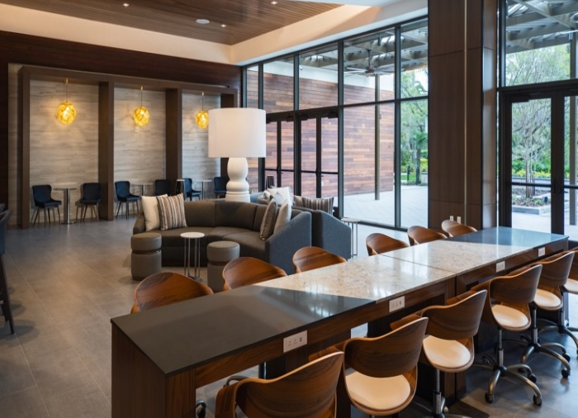
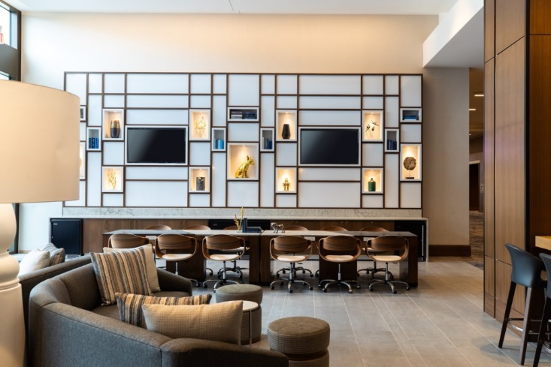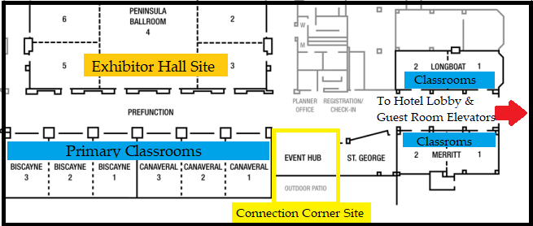
The 2023 FIFEC Connection Corner is SPECTACULAR!
The FIFEC Connection Corner became an instant hit the moment it was introduced. Our attendees enjoy having a space within the convention center where they can meet & network with others, or just sit for a moment away from the crowd.
This beautiful space is fully furnished, well-equipped, tastefully appointed and even features an outdoor patio. It is also located right in the middle of all of the FIFEC Conference action! (See the map below!)
The Connection Corner sponsor personalizes the room by bringing their promotional materials to the space.
The FIFEC Connection Corner will be available until 7:30 pm should the sponsor decide to host an event after classes have ended for the day.
(All Connection Corner events must be approved in advance by the FIFEC Executive Board.)

Do Not Disturb Signs Bid Amount:
This novel idea serves to promote your firm throughout the day and night. Each registered attendee will receive one of these Do Not Disturb door signs with your logo and design to use during their stay at the Renaissance Orlando. When the conference ends on Friday, they take this practical and unique souvenir home to clearly denote when it’s time for uninterrupted work, studying, resting, exercising, meditation or time out. We recommend ordering 800 units.

FIFEC Awards Luncheon Banquet Add-On Add - $1,500.00
This is the premier event at the conference. The moment when we all gather to break bread and celebrate the remarkable accomplishments of dedicated Florida fraud fighters. Not only are all conference attendees present but so are the nominees and their invited guests. This provides the ultimate opportunity for conference exposure.
This is being offered as an optional add-on to your Pearl Sponsorship. No bidding is required. Simply check the boxes and we will add the $1,500.00 contribution to your total winning bid. Awards Luncheon Banquet Sponsors will receive an additional complimentary conference registration!
The Awards Luncheon Banquet sponsors will be recognized on the centerpiece cards at each table, at the start of the Awards presentation and in the loop that plays continuously throughout the luncheon.

Please complete this section below after you have selected your sponsorships and email the form to Aaron Quarterman at sponsors@fifec.org by April 30, 2023. You will be notified of the bid results after April 30 and be provided with additional information at that time.
Company Information:

- Firm’s Name: To ensure accuracy, please indicate exactly how you want your firm listed, i.e.: P.A vs. PA; LLP vs. L.L.P., etc.:
- Contact Person:
- Contact Person’s Phone Number:
- Contact Person’s Email Address:

Thank you for your Sponsorship. We’ll see you in July!
2023 FIFEC Sponsors Subcommittee

